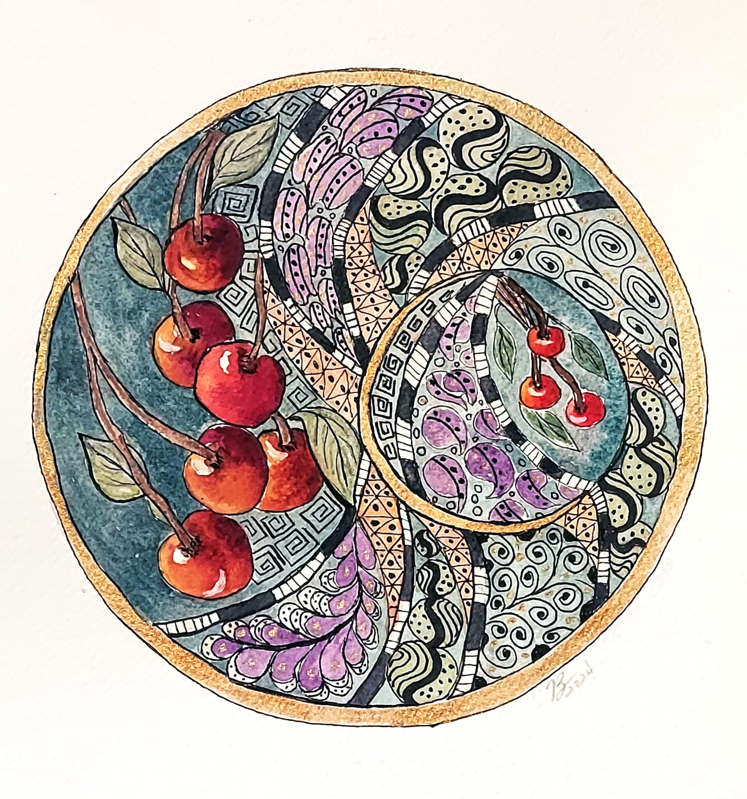
Presenting: Zen-Inspired Art Workshop
Tuesday, November 18, 2025 | 6:30 p.m.
FREEHOLD ELKS LODGE, 73 E MAIN STREET, FREEHOLD
Please join us as we are introduced to this Zen-Inspired Workshop by our member, Beth Stamp who has graciously agreed to guide us through her process. Beth will teach us a few patterns and participants are encouraged to bring any unfinished art or paintings (watercolor or pencil) you would enjoy tangling on. Tangling works best on flat paper rather than acrylic or oil paintings. You might also enjoy tangling on a page from a magazine. If you have, please bring a Micron Pen or Sharpie Fine Marker. Supplies will also be available.

Our General Meeting Events are FREE & Open to the Public.

PLEASE RSVP to FreeholdArtSociety60@gmail.com

